**Ansible Software**

**Documentation for windows systems**

**Windows host setup:**

PowerShell (RUN IT AS ADMINISTRATOR)

1)Ansible requires PowerShell version 3.0 or newer.

Command used to check its version:

$psversiontable

Winrm

1)Run this command.

winrm enumerate winrm**/**config**/**Listener

if this error received

then execute this command: “winrm quickconfig” and when prompted click y.

Once done execute the first command again.

**Linux server setup:**

I have used ubuntu 20.04 version

Enter into root user using su command and execute the following commands:

* apt-add-repository ppa:ansible/ansible
* apt update
* apt install ansible
* apt install python3-pip
* pip install pywinrm
* gedit /etc/ansible/hosts

copy these to the hosts file and edit where ever necessary

[windows]

HOST IPV4 ADDRESS

[windows:vars]

ansible_user=USERNAME OF THE HOST MACHINE

ansible_password=ITS PASSWORD

ansible_port=5985 or 5986(BASED ON YOUR WINRM CONFIGURATION)

ansible_connection=winrm

ansible_winrm_server_cert_validation=ignore

* ansible windows -m win_ping

ON SUCCESS:

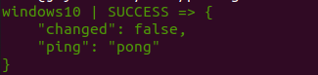

FAILURE:

1. **if receiving error:**

First try pinging the host machine’s ip address from the server if it is not able to ping follow these steps else skip.

Go to the windows host machine and execute the following steps:

1. Launch the Windows 10 host VM and log in as an administrator.
2. Open the Windows Firewall settings by typing "Windows Firewall" in the Start menu search and selecting "Windows Defender Firewall."
3. In the Windows Defender Firewall window, click on "Advanced settings" on the left-hand side.
4. In the Windows Defender Firewall with Advanced Security window, click on "Inbound Rules" in the left-hand pane.
5. In the Actions pane on the right-hand side, click on "New Rule."
6. The New Inbound Rule Wizard will open. Select "Custom" and click "Next."
7. Choose "All Programs" and click "Next."
8. Under "Protocol type," select "ICMPv4" and click "Next."
9. In the "Customize ICMP Settings" window, make sure "Echo Request" is selected, and click "OK" and then "Next."
10. Select "Allow the connection" and click "Next."
11. Leave all the profiles selected (Domain, Private, Public) and click "Next."
12. Give the rule a name, such as "Allow ICMP Echo Request," and provide an optional description. Click "Finish."
13. **If receiving this error in server:**

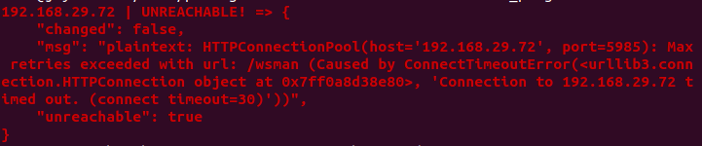

We need to create rule to allow winrm traffic in windows host machine

1. Open the Windows Firewall settings by typing "Windows Firewall" in the Start menu search and selecting "Windows Defender Firewall."
2. In the Windows Defender Firewall window, click on "Advanced settings" on the left-hand side.
3. In the Windows Defender Firewall with Advanced Security window, click on "Inbound Rules" in the left-hand pane.
4. In the Actions pane on the right-hand side, click on "New Rule."
5. The New Inbound Rule Wizard will open. Select the rule type as "Port" and click "Next."
6. Choose "TCP" as the protocol, and select "Specific local ports." Enter "5985" for HTTP or "5986" for HTTPS. Click "Next."
7. Select "Allow the connection" and click "Next."
8. Leave all the profiles selected (Domain, Private, Public) and click "Next."
9. Give the rule a name, such as "Allow WinRM Incoming," and provide an optional description. Click "Finish."
10. **If receiving this error in server:**

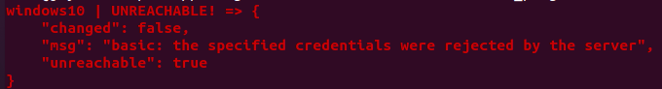

Go to the windows host machine and in the PowerShell (must be running as admin) and execute these commands

1. Set-Item -Force WSMan:\localhost\Client\Allowunencrypted $True
2. Set-Item -Force WSMan:\localhost\Service\Allowunencrypted $True

If receiving this error:

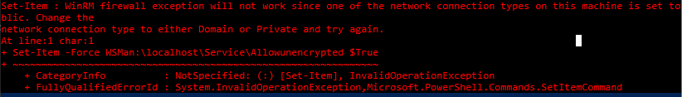

Follow the following video to change network type from public to private or domain in you windows host machine:

For wifi:

<https://www.youtube.com/watch?v=o9Vlv-DOiLo>

For Ethernet:

<https://www.youtube.com/watch?v=RdvLho09z3A>

1. Set-Item -Force WSMan:\localhost\Service\auth\Basic $True

These must fix any type of errors that may occur and once you receive the success message continue further with the following steps in the linux server.

* Write a sample.yml file using gedit sample.yml command

File content – To create a folder named Ansible in the C Drive of the host windows machine

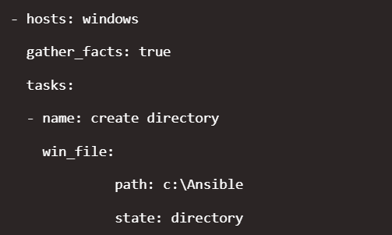

* ansible-playbook sample.yml --syntax-check

output should be something like this:



* last command to execute the playbook:

ansible-playbook sample.yml

output:

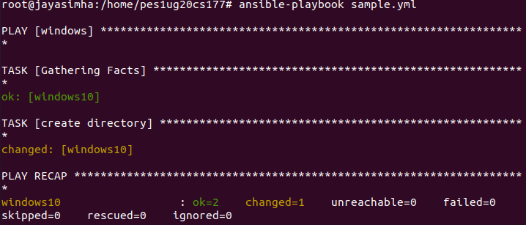

Output in the windows host machine a directory is created in the C Drive.

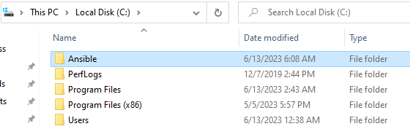

**Thank You**